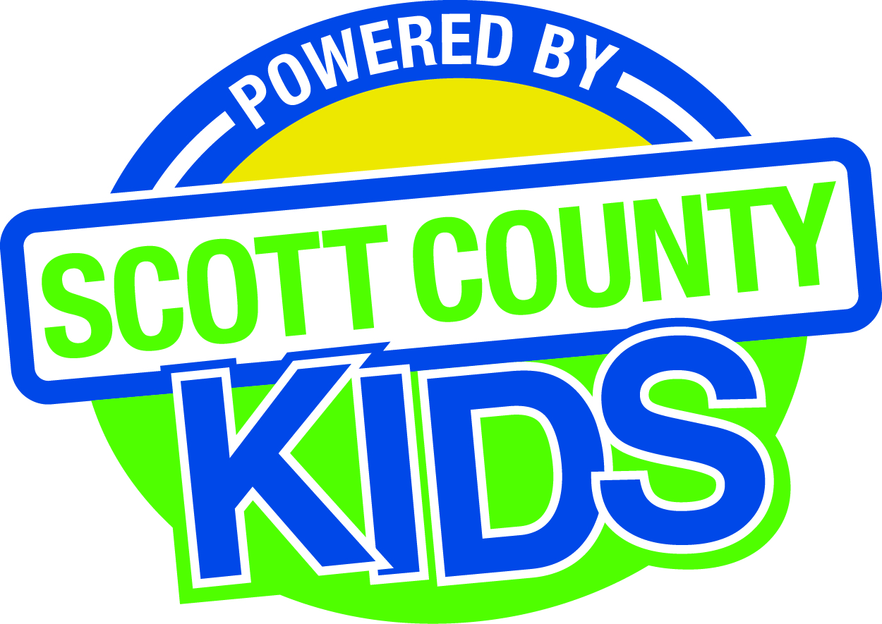 | Scott County Kids Early Childhood Iowa Board Agenda  October 6, 2026 12:30-2:00 PM  Room 638  600 W. 4th Street l Davenport, Iowa 52801  Or via Zoom  https://us06web.zoom.us/j/82449020058?pwd=OCefAPRaV5G3XMfXpkXuDaonuVbyYi.1

Time | Item | Action/Information
12:30 PM | Welcome/Introductions | Information
12:35 PM | Approval of minutes of September 1, 2026 | Action Item
12:40 PM | FY27 Expenditure Report | Information
12:50 PM | Scholarships -proposal to increase contract | Action Item
1:00 PM | HOPES/PAT -proposal to increase contract | Action Item
1:05 PM | Strategic Plan | Action Item
1:15 PM | Nominations  -renewal of memberships  -approval of new board members | Action Item
1:20 PM | Bylaws | Information/Action
1:25 PM | State ECI Updates | Information
1:30 PM | Other Business | Information
1:35 PM | Public Input | Information
1:40 PM | Adjourn | Action Item

Next Meeting: November 3, 2026

